Project Report for Computer Networks

**Design and Implementation of**

**Networking in University**

**BACHELORS OF COMPUTER SCIENCE**

By

Muhammad Azeem Qureshi 20601

Javaid Ahmed 21521



Under the Guidance of

Sir Shahid Mahmood

(July-2022)

**Riphah School of Computing Science**

**Riphah International University**

**Lahore, Pakistan**

ABSTRACT

Computer networks have a significant impact on the working of an organization. Universities depend on the proper functioning and analysis of their networks for education, administration, communication, e-library, automation, etc. An efficient network is essential to facilitate the systematic and cost-efficient transfer of information in an organization in the form of messages, files, and resources. The project provides insights into various concepts such as topology design, IP address configuration, and how to send information in the form of packets to the wireless networks of different areas of a University.

The aim of this project is to design the topology of the university network using the software Cisco Packet Tracer with the implementation of wireless networking systems. This university network consists of the following devices:

1) Router (PT-Router)

2) Switches (2950-24)

3) DHCP server

4) DNS server

5) WEB server (HTTP)

6) Wireless Device (Access Points)

7) PCs

8) Laptops

9) Printers

10) Smartphones

The design includes the following parts of the University:

A-Block: Admin, Chairman, Camera Room, HR.

B-Block: Library, Student Services Department, Classrooms

C-Block: English Department, IT-Department

Hostel Blocks: Girls Block and Boys Block

INTRODUCTION

* **Motivation**

The word “digital” is very significant in today’s world, with an increase in the development of technology the entire world is moving towards the digital era. The educational institution plays an important role in this digitalization, hence the campus should adapt to digital means of networking as well and become a “digital campus”. Going wireless plays an important role in this digitalization. The wireless network makes the connection easy with a reduction in the use of wires or cables. A wired connection makes it difficult to keep track of all the devices and to manage the cable connection, which is not only chaotic but also challenging to handle.

Campus networking via wireless connection becomes an important part of campus life and provides the main way for teachers and students to access educational resources, which gives an important platform to exchange information. As laptops and intelligent terminals are widely used, demand for access to information anytime and anywhere has become more and more urgent, but traditional cable networks cannot meet this requirement. Then wireless network construction becomes necessary and essential. The wireless network is one of the important components of a digital campus and wisdom campus. It provides an efficient way to explore the internet with a mobile terminal for teachers and students regardless of cables and places. This is an important mark of the modern campus as a supplement of a cable network. With the development of network and communication technology, cable networks on a university campus bring much convenience for teaching and research work. But for mobility and flexibility, it has obvious shortcomings. A wireless network can overcome these drawbacks and has been applied to the university campus.

* **Project Statement**

In this mini-project, we defined a simulation of campus networks based on wired networking. The network is divided into three sets: For the campus area and the other for the hostel area and Classrooms. The major aim of this project is to show the wireless and wired connectivity that is used in universities to make the network efficient and mobile at the same time. In order to provide equal functionality to all the users (college staff and students), we have added DNS and HTTP servers for the maximum utilization of resources.

Hence the campus network provides different services such as connecting the user to the internet, data sharing among users (students, teachers, and different university members), accessing different web services for different functionalities, so it needs wired networking for smooth processing.

LITERATURE REVIEW

* What is Packet Tracer?

Packet Tracer is a cross-platform visual simulation tool designed by Cisco Systems that allows users to create network topologies and imitate modern computer networks. The software allows users to simulate the configuration of Cisco routers and switches using a simulated command-line interface. Packet Tracer makes use of a drag-and-drop user interface, allowing users to add and remove simulated network devices as they see fit. The software is mainly focused on Certified Cisco Network Associate Academy students as an educational tool for helping them learn fundamental CCNA concepts. Previously students enrolled in a CCNA Academy program could freely download and use the tool free of charge for educational use.

* Router

A router is a device like a switch that routes data packets based on their IP addresses. The router is mainly a Network Layer device. Routers normally connect LANs and WANs together and have a dynamically updating routing table based on which they make decisions on routing the data packets. Router divides broadcast domains of hosts connected through it.

* Switch

A network switch (also called switching hub, bridging hub, officially MAC Bridge is networking hardware that connects devices on a computer network by using packet switching to receive and forward data to the destination device. A network switch is a multiport network bridge that uses MAC addresses to forward data at the data link layer (layer 2) of the OSI model. Some switches can also forward data at the network layer (layer 3) by additionally incorporating routing functionality. Such switches are commonly known as layer-3 switches or multilayer switches.

* Network Packet

A network packet is a formatted unit of data carried by a packet-switched network. A packet consists of control information and user data, which is also known as the payload.

* Server

A server is a computer or system that provides resources, data, services, or programs to other computers, known as clients, over a network. In theory, whenever computers share resources with client machines they are considered servers. There are many types of servers, including web servers, mail servers, and virtual servers.

Many networks contain one or more of the common servers. The servers used in our project are as follows:

* DNS Server

DNS stands for Domain Name System servers which are application servers that provide a human-friendly naming method to the user computers in order to make IP addresses readable by users. The DNS system is a widely distributed database of names and other DNS servers, each of which can be used to request an otherwise unknown computer name. When a user needs the address of a system, it sends a DNS request with the name of the desired resource to a DNS server. The DNS server responds with the necessary IP address from its table of names.

* WEB Server

One of the widely used servers in today’s market is a web server. A web server is a special kind of application server that hosts programs and data requested by users across the Internet or an intranet. Web servers respond to requests from browsers running on client computers for web pages, or other web-based services.

* DHCP Server

A DHCP Server is a network server that automatically provides and assigns IP addresses, default gateways and other network parameters to client devices. It relies on the standard protocol known as Dynamic Host Configuration Protocol or DHCP to respond to broadcast queries by clients. DHCP server automatically sends the required network parameters for clients to properly communicate on the network. Without it, the network administrator has to manually set up every client that joins the network, which can be cumbersome, especially in large networks. DHCP servers usually assign each client with a unique dynamic IP address, which changes when the client’s lease for that IP address has expired.

* Wireless Network

A wireless network broadcasts an access signal to the workstations or PCs. This enables mobility among laptops, tablets, and PCs from room to room while maintaining a firm network connection continuously. A wireless network also presents additional security requirements.

* Ethernet

This is the backbone of our network. It consists of the cabling and is typically able to transfer data at a rate of 100mb/s. It is a system for connecting a number of computer systems to form a local area network, with protocols to control the passing of information and to avoid simultaneous transmission by two or more systems. Among the different types of Ethernet, we have used Gigabit Ethernet, which is a type of Ethernet network capable of transferring data at a rate of 1000 Mbps and fast Ethernet is a type of Ethernet network that can transfer data at a rate of 100 Mbps.

* Computing Device

Computing devices are the electronic devices that take user inputs, process the inputs, and then provide us with the end results. These devices may be Smartphones, PC Desktops, Laptops, printer, and many more.

* Internet Protocol

Internet Protocol (IP) is one of the fundamental protocols that allow the internet to work. IP addresses are a unique set of numbers on each network and they allow machines to address each other across a network. It is implemented on the internet layer in the IP/TCP model.

WORK DONE

In order to make our project understandable, we have divided the content into steps. They are as follows:

1. **Software and hardware requirements**

Before heading towards the implementation we need to make sure of the following requirements.

* A proper workstation (any mid-high range laptop will suffice).
* Packet Tracer by Cisco
* 8 GB RAM.
* Any 10,000+ Average CPU Mark scored processor.
* 16 GB of dedicated hard disk space.

1. **Network Requirements**

Riphah International University Lahore outline is considered for this university network.

The network is divided into 3 areas:

1. A-Block Area

The A-Block area is further divided into various parts like Admin, Chairman, Camera Room, HR and Server Room.

1. B-Block Area

The B-Block area is further divided into library, SSD, Classrooms respectively.

1. C-Block Area

The C-Block area is further divided into English and IT Department, Boys blocks and Girls blocks respectively.

Devices Used In the Network

|  |  |
| --- | --- |
| Devices | Quantity |
| 1) Router (PT) | 3 |
| 2) Switches (2950-24) | 14 |
| 3) DHCP server | 1 |
| 4) DNS server | 1 |
| 5) WEB server (HTTP) | 1 |
| 6) Wireless Device (Access Point) | 3 |
| 7) PCs | 43 |
| 8) Laptops | 2 |
| 9) Smartphones | 8 |
| 10) Printers | 8 |

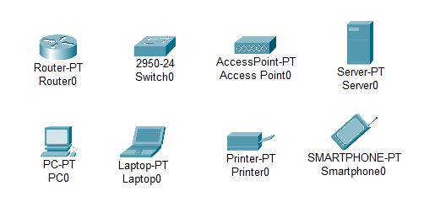

1. **Configuring IP Addresses**

We have attached the screenshots of all the IP configuration below:

**A-Block Router**

FAST ETHERNET 0/0

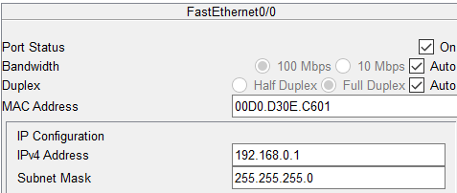

SERIAL 0/1/0

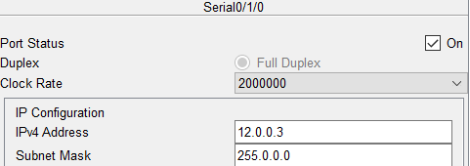

SERIAL 0/1/1

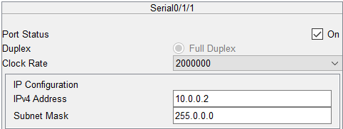

**B-Block Router**

FAST ETHERNET 0/0

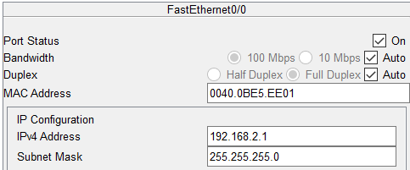

SERIAL 0/1/0

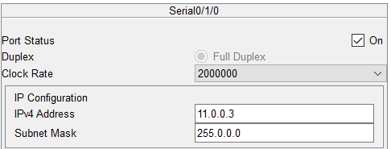

SERIAL 0/1/1

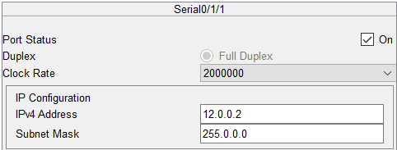

**C-Block Router**

FAST ETHERNET 0/0

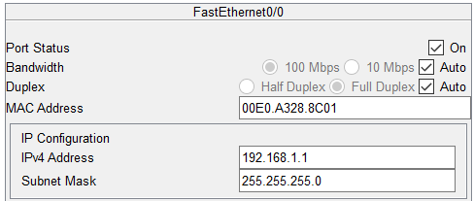

SERIAL 0/1/0

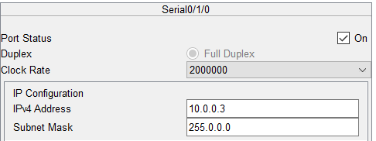

SERIAL 0/1/1

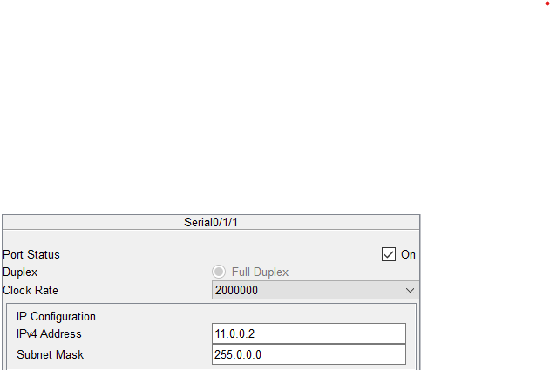

**HTTP SERVER**

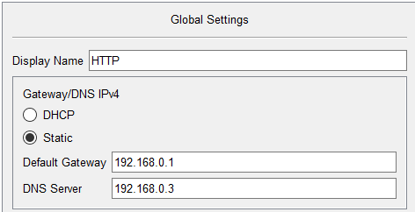

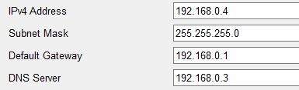

**DHCP SERVER**

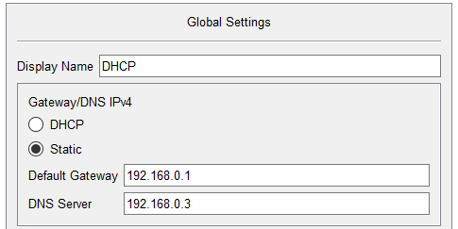

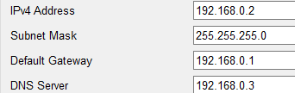

**DNS SERVER**

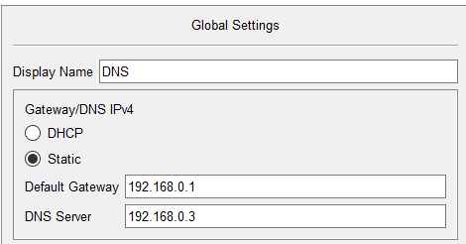

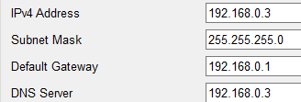

**A-BLOCK DIAGRAM**

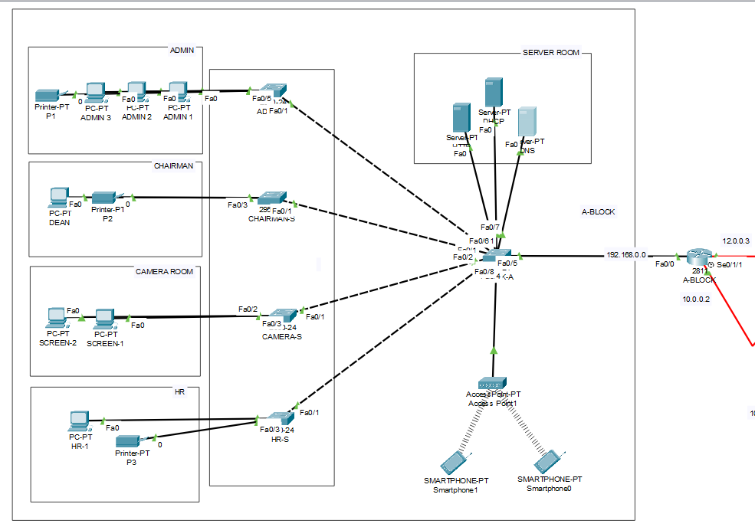

IP Address are as follows

Subnet Mask- 255.255.255.0

Default Gateway- 192.168.0.1

DNS Server- 192.168.0.3

**B-BLOCK DIAGRAM**

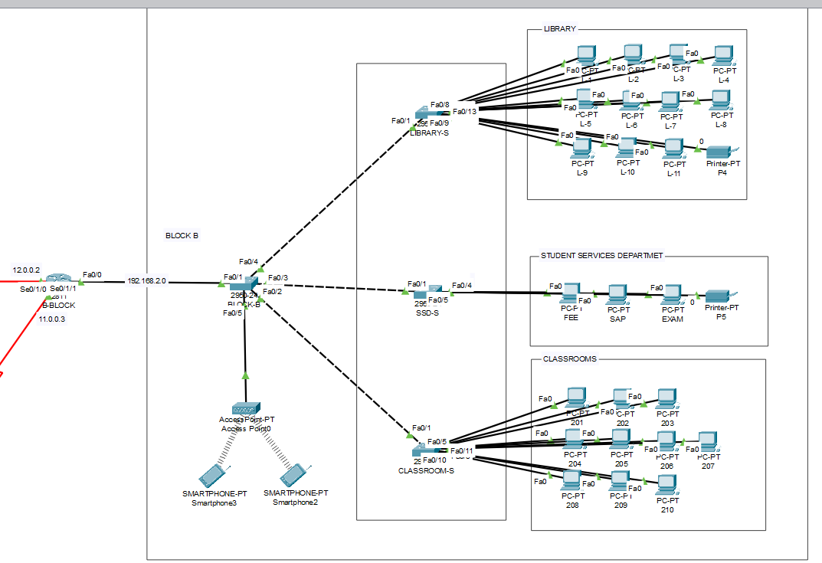

IP Address are as follows

Subnet Mask- 255.255.255.0

Default Gateway- 192.168.1.1

DNS Server- 192.168.0.3

**C-BLOCK**

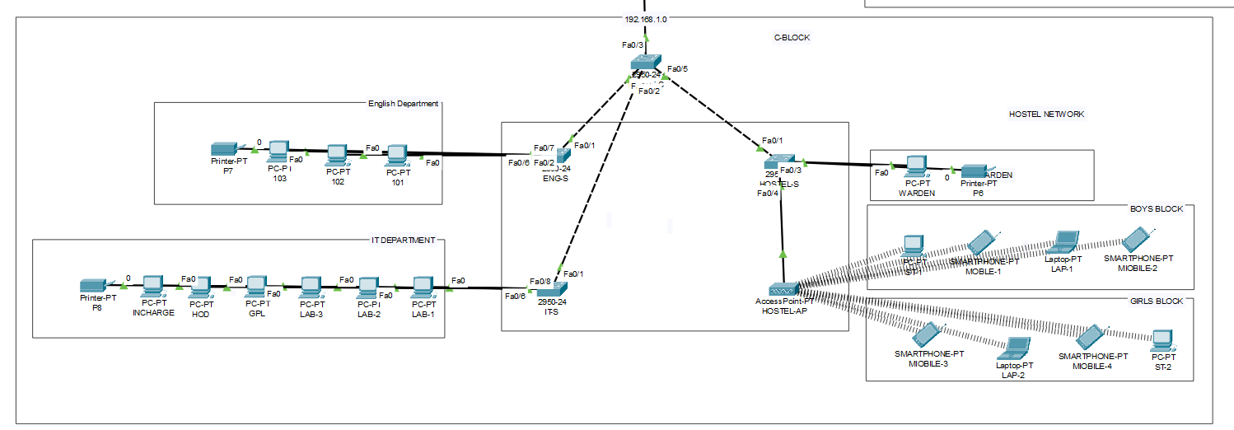

IP Address are as follows

Subnet Mask- 255.255.255.0

Default Gateway- 192.168.2.1

DNS Server- 192.168.0.3

**FINAL SIMULATION**

In Simulation Mode, you can watch your network run at a slower pace, observing the paths that packets take and inspecting them in detail. The proposed architecture, when simulated on Cisco Packet Tracer, produced results which are demonstrated as follows

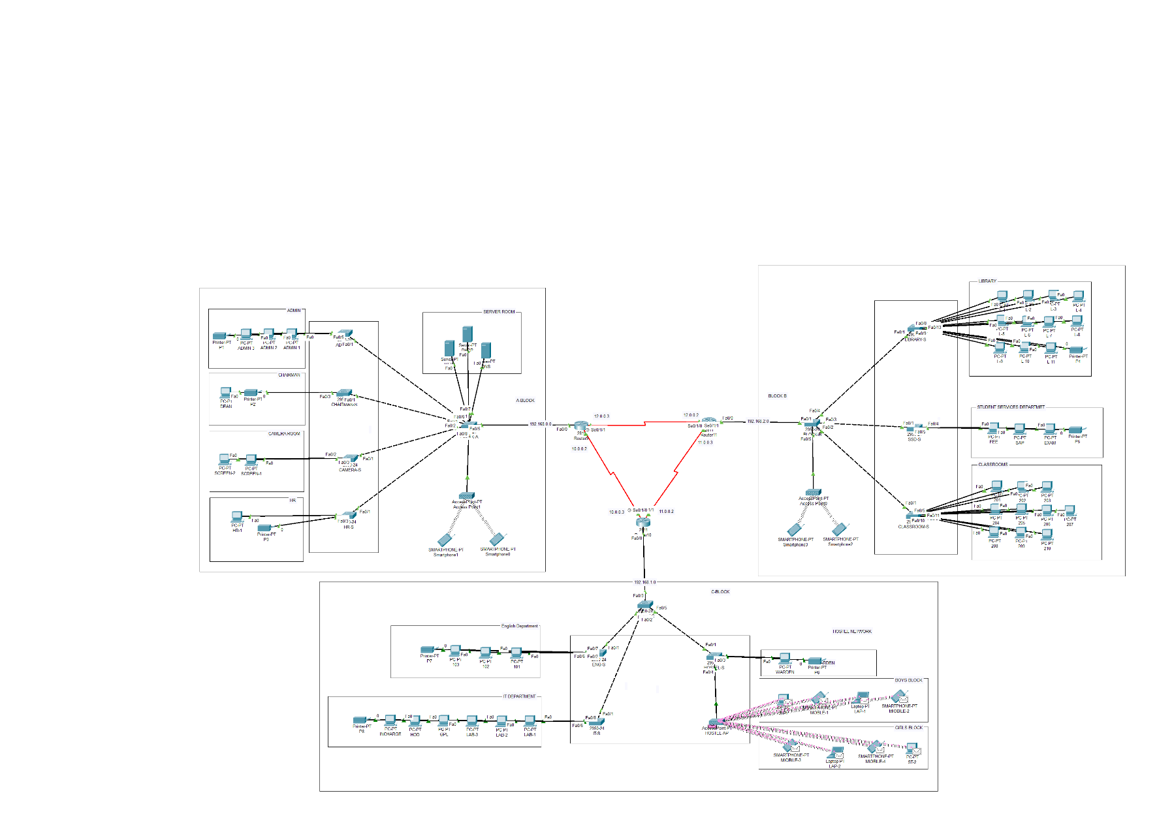

The complete diagram of the University Area Network Scenario created in Packet Tracer environment